Endangered Species: Maui Dolphins
Student’s Name:
Institutional Affiliation

Table of Contents
- Terms of Reference………………………………………………………………………3
- Procedure…………………………………………………………………………………3
- Findings……………………………………………………………………..……………4
  - Conservation of Maui Species……………...……………………………………..…..4
  - Who is Responsible for Maui Protection……………………………………………5
- Conclusion……………………………………………………………………………..…7
  - Effects on Maui and Non- Target Species…………………………………………8
- Recommendations………………………………………………………………………10
  - Effects on Maui and Non- Target Species…………………………………………10
  - Who is Responsible for Maui Protection…………………………….………………11
- References…………………………………………………………………………….…13

- Terms of Reference
The report is based on the feedback to the Department of Conservation (DoC) on the endangerment of the Maui dolphin species. The endangerment of the species has been brought about by set netting and trawling fishing practices. These practices are common along shores and harbors, which are prime areas for these dolphins. The fishermen take advantage of the dolphin’s inability to detect the fishermen’s nets (with fine filaments) (Burns 2014, para. 4). Negative reactions have been evoked resulting into anti- trawling movements by locals who are opposed to the manner in which fishermen hunt these species despite their critical numbers. There has been an outcry from the general public to Government large exclusion zones for the Maui dolphins. According to Liz Slooten, there has been a 93% decline on the population of these dolphins between 1970 and 2009.
Furthermore, their population has been shockingly decimated to 55 between 2012 and 2014 (Burns, 2014, para. 5). Also, concerns have been expressed since the proportion of the female dolphins that are of breeding age, are only ten in number In addition, it has a long breeding period ranging from 7 to 9 years, therefore rapid multiplication of this species virtually impossible The species is also susceptible to genetic disorders due to their small population (birth abnormalities and higher mortality rates). In case of a disease outbreak, fear is the entire species can be wiped out. These diseases include: Brucellocis and Toxoplasmosis (para. 6). The research proposes stringent conservation measures; since the death of even one of the potential females will strike a blow to the survival of this species. The report will lay emphasis on the implication of poor fishing on the population of the dolphins in New Zealand. The report was enquired on 26/ 9/ 2018 and it is due for submission on 26/ 9/ 2018.
2.0 Procedure
The information in compiling the report for this research is a collection of different publications including:
- Online publications retrieved using the keyword (Maui dolphins).
- Websites such as: Green Global Travel.com, NZ Herald.com, Gov. NZ.com
- Conducting interviews and using questionnaires to obtain feedback on the Maui species from the locals of New Zealand.
- Reviewing online videos from social media platforms such as: Face book and You Tube and other web line videos.
- Personal blog sites.

3 Findings
The research established that the Government has implemented radical measures in order to protect the species. This has been evidenced when it banned netting practices in most areas of New Zealand. These efforts are still lagged behind by the Government’s refusal to increase the number of protective zones under the guise that these species do not face threat in their supposed habitats. For instance, in the year 2014, the government was seen to protect their oil- drilling activities along the West Coast (3000km sq. land) which harbors a sanctuary for marine mammals (Burns, 2014, para. 8). The area is a major habitat for the Maui and occupies a quarter of the sanctuary. Therefore the government is evidently protecting its economical interests at the sake of a species that is on the brink of extinction. The sanctuaries are favorable breeding conditions for the few surviving Maui whose population might plummet in the subsequent years if they properly protected.
Also, conservationists (for example The International Whaling Commission) have extensively advocated for the safeguard of this species. They have lobbied for the complete ban on trawl and gill netting especially on main habitats of the Maui. Therefore heeding to international fears, the Government banned fishing on the area within 2 nautical miles around the Plymouth shore (New Zealand Herald, 2012, para. 1). In addition, officers were sent to the ground to continuously monitor and record on their log books the dimensions of the available fishing nets; the acceptable dimensions standing between 2nm to 9nm. The fishermen had to cover the expenses incurred by the observers which approximated to $1000 per day (para. 2).
3.1 Conservation of the Maui Dolphin
The sighting and recovering of these dolphins had seen the Government invest tremendous amounts of efforts. Search parties had covered 4540 nm in a span of 168 days on both internal and external of these restriction zones but there was no Maui dolphin sighted. Despite the Government’s efforts to restrict areas which are potential habitats for the dolphins, there are reports of some areas had zero population of the Maui. For instance, the Taranaki area heightened the tension between the local fishermen and the Government.
  - Who is Responsible for Maui Protection?
The protection of the Māui dolphin has experienced major bureaucratic setbacks over the years. Organisations and individuals play an important role in the Māui dolphin’s conservation. The ultimate legal responsibility is endowed the Government of New Zealand’s to conserve its flora and fauna through acts of parliament, international agreements, directions of the current affairs, and statutory requirements. There should be a balance of the Government’s responsibilities to its biodiversity and the economic and social wellbeing of the people of New Zealand. These responsibilities can only be primarily exercised through directions from the official Minister who has been accorded specific legal obligations. In the case of Māui dolphin, the Minister for Conservation and Primary Industries is held accountable. The Minister through the departments the Department of Conservation (DOC) have the prime responsibility for implementing these ministerial measures into actions, as well legislation and international directions. Incorporation of the views of the community is also necessary when possible. The DOC is tasked with managing the protection of Māui dolphins taking into account the statutory aspects It is also has the responsibility of evaluation the diverse impacts of fishing on the species. 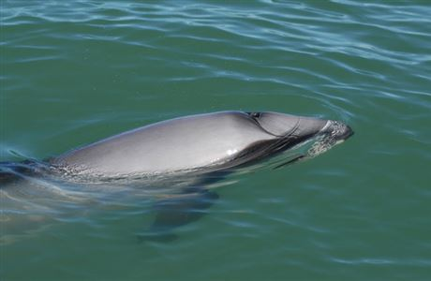
Fig.1 The Maui swimming above the surface of the water (2018).

4. Conclusion
From the empirical evidence that the research has provided, it Government might be a bit late in the conservation of the Maui. Therefore, I have a strong conviction that the DoC and other stakeholders can adopt other effective conservation alternatives. Also, fishing in restricted areas should be banned completely in the restricted areas to ensure the survival of the species.
4.1 Effects on Maui and Non- Targeted Species
The dolphins have indistinguishable characteristics to the Hector’s dolphins; they only differ genetically due to their DNA composition. Therefore Hector dolphins are larger, have thicker snout, and have a slightly taller. Both subspecies have one distinct characteristic (rounded ear and dorsal fin) which differentiates them from the other species of dolphins in the New Zealand waters. Therefore, these sub- species may also fall victim to the fisherman’s trawling activities. The later live in small groups of approximately 12 dolphins, and have a daily coverage of at least 80 km (Endangered Species, 2018). Therefore, these characteristics make them more susceptible to capturing by the fishermen. In addition, the uncertainty that exist about the distribution of Māui dolphins makes sighting and conservation of these species difficult. Currently, Māui dolphins are majorly found at Maunganui Bluff and Whanganui coastlines, also between Manukau and Raglan harbors which are common fishing grounds. The dolphins often swim offshore to approximately 100 m depth, and may fall victim to the trawling nets (Endangered Species, 2018). These dolphins feed on a variety of small fish including: red cod arrow squid, sole, and stargazer. The reduction in population of these dolphins may lead to ecological imbalances.
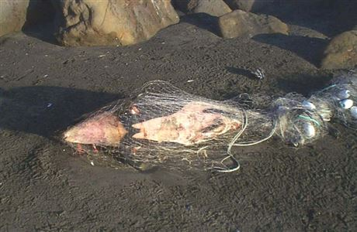
Fig. 2 Dead Shark at the Taranaki Coast (2017)
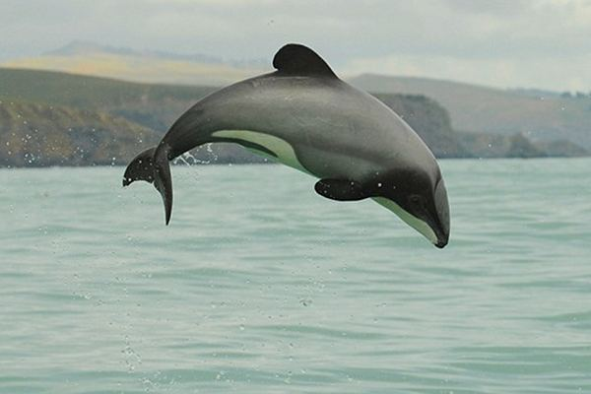
Fig. 3 The Maui diving above the surface (2018)
5. Recommendations
The report recommends the that the fishermen should adopt alternative fishing techniques and advocate for the abolishment of the net fishing and trawling. The research discussed the following alternative solutions below in a bid to eliminate the 1080 poison.
5.1 Maui Dolphin and Non- Targeted Species
The Government should set MMS boundaries and the fishing-related controls that would be applied with certainty over the exact range of the dolphins, both offshore and onshore (especially in the Taranaki area). In the year 2012, the dolphin was caught by a Taranaki net link along the coast. From the empirical evidence, only 55 dolphins are existing currently. Therefore, DOC and MPI should seek submissions on some interim measures to protect this species along the New Zealand Coast. These interim measures also include the ban on set net use within 2 nautical miles along the Taranaki coast to the south of the MMS and extending to the coast adjacent to the town of Hawera (Herald, 2012, para. 3). Commercial set net use along this coast out to 7 nautical miles was restricted to vessels with an MPI observer
5.2Who is Responsible for the protection of the Maui?
Due complicated nature of the Maui protection process, there are recommendations of more stakeholders to be involved. The stakeholders who have been proposed to help in the conservation of the Māui dolphin include: non- governmental organizations (NGOs) who will be mantled with echoing the plight of these dolphins at national and international levels. These NGOs should be preferably non- profitable. Conservation process entails a coherent voice of their membership for rapid implementation of the conservation measures enacted. The Government should provide favorable conditions for these organizations to operate in. Collectively, both the Government and NGOs will be powerful lobbyists as lobbying will occurs directly through the government officials and the public through various media. The usage of these media should focus on the contentious issues impact of their cause on the public more meaningful.

6.0 References
Burns S. (3 Dec 2014).Endangered Species Spotlight: Maui Dolphin.Retrieved on 26TH, Sept.
2018 Green Global.com website: https://greenglobaltravel.com/maui-dolphin/
NZ Herald Magazine (31 Jan. 2012). Maui’s Dolphins Swimming in a Sea of Trouble.Retrieved
26TH Sept. 2018 from NZHerald.com website:
https://www.nzherald.co.nz/nz/news/article.cfm?c_id=1&objectid=10844715
NZ Herald Magazine (15 March 2015). NZ Need to do the Right Thing to Save Maui. Retrieved
on 26TH Sept. NZHerald.com w https://www.nzherald.co.nz/nz/news/article.cfm?c_id=1&objectid=11271367ebsite:
Endangered Species (14 March2018). Maui Dolphins. Retrieved on 26TH Sept. 2018 from Org.
NZ.com website:
http://www.endangeredspecies.org.nz/store/doc/Maui%20dolphin%20Endangered%

Images:
Figure 1: Govt. Org. Department of Conservation. Retrieved on 26TH Sept.
2018: https://www.doc.govt.nz/thumbs/gallery/link/be54499fb93a41d98f7c9a47f49db0b6.jpg
Figure 2:Govt. Org. Department of ConservationRetrieved on 26TH Sept.
https://www.doc.govt.nz/thumbs/gallery/link/a92ccea44e9746fea3593ca72a0cff88.jpg
Figure 3: Green Global Travel.com. Endangered Species Spotlight. Retrieved on 26TH Sept.
https://greenglobaltravel.com/wp-content/uploads/Maui-

